SN-CA-B3 - Project 1-Foundamental
Complete topology, subnetting, router configurations, verification and testing

1. IP Addressing Plan
Device | Interface | IP Address | Mask | Network/Purpose
Win-1 | NIC | 10.0.0.10 | /24 | 10.0.0.0/24 LAN
R1 | e0/0 | 10.0.0.1 | /24 | Win-1 LAN
R1 | e0/1 | 20.0.0.1 | /30 | R1-R2
R2 | e0/0 | 20.0.0.2 | /30 | R1-R2
R2 | e0/1 | 30.0.0.1 | /30 | R2-R3
R3 | e0/0 | 30.0.0.2 | /30 | R2-R3
R3 | e0/1 | 172.19.0.1 | /30 | R3-R4
R4 | e0/1 | 172.19.0.2 | /30 | R3-R4
R4 | e0/0 | 15.0.0.1 | /24 | Win-2 LAN
Win-2 | NIC | 15.0.0.10 | /24 | 15.0.0.0/24 LAN
R3 | e0/2 | 21.0.0.1 | /30 | R3-R5
R5 | e0/0 | 21.0.0.2 | /30 | R3-R5
R5 | e0/1 | 192.168.168.1 | /30 | R5-R6
R6 | e0/1 | 192.168.168.2 | /30 | R5-R6
R6 | e0/0 | 162.14.0.1 | /24 | Win-3 LAN
Win-3 | NIC | 162.14.0.10 | /24 | 162.14.0.0/24 LAN

2. R1 Complete Configuration
enable
configure terminal
hostname R1
interface e0/0
ip address 10.0.0.1 255.255.255.0
no shutdown
exit
interface e0/1
ip address 20.0.0.1 255.255.255.252
no shutdown
exit
ip route 30.0.0.0 255.255.255.252 20.0.0.2
ip route 172.19.0.0 255.255.255.252 20.0.0.2
ip route 15.0.0.0 255.255.255.0 20.0.0.2
ip route 21.0.0.0 255.255.255.252 20.0.0.2
ip route 192.168.168.0 255.255.255.252 20.0.0.2
ip route 162.14.0.0 255.255.255.0 20.0.0.2
end
write memory

3. R2 Complete Configuration
enable
configure terminal
hostname R2
interface e0/0
ip address 20.0.0.2 255.255.255.252
no shutdown
exit
interface e0/1
ip address 30.0.0.1 255.255.255.252
no shutdown
exit
ip route 10.0.0.0 255.255.255.0 20.0.0.1
ip route 172.19.0.0 255.255.255.252 30.0.0.2
ip route 15.0.0.0 255.255.255.0 30.0.0.2
ip route 21.0.0.0 255.255.255.252 30.0.0.2
ip route 192.168.168.0 255.255.255.252 30.0.0.2
ip route 162.14.0.0 255.255.255.0 30.0.0.2
end
write memory

4. R3 Complete Configuration
enable
configure terminal
hostname R3
interface e0/0
ip address 30.0.0.2 255.255.255.252
no shutdown
exit
interface e0/1
ip address 172.19.0.1 255.255.255.252
no shutdown
exit
interface e0/2
ip address 21.0.0.1 255.255.255.252
no shutdown
exit
ip route 10.0.0.0 255.255.255.0 30.0.0.1
ip route 20.0.0.0 255.255.255.252 30.0.0.1
ip route 15.0.0.0 255.255.255.0 172.19.0.2
ip route 192.168.168.0 255.255.255.252 21.0.0.2
ip route 162.14.0.0 255.255.255.0 21.0.0.2
end
write memory

5. R4 Complete Configuration
enable
configure terminal
hostname R4
interface e0/1
ip address 172.19.0.2 255.255.255.252
no shutdown
exit
interface e0/0
ip address 15.0.0.1 255.255.255.0
no shutdown
exit
ip route 10.0.0.0 255.255.255.0 172.19.0.1
ip route 20.0.0.0 255.255.255.252 172.19.0.1
ip route 30.0.0.0 255.255.255.252 172.19.0.1
ip route 21.0.0.0 255.255.255.252 172.19.0.1
ip route 192.168.168.0 255.255.255.252 172.19.0.1
ip route 162.14.0.0 255.255.255.0 172.19.0.1
end
write memory

6. R5 Complete Configuration
enable
configure terminal
hostname R5
interface e0/0
ip address 21.0.0.2 255.255.255.252
no shutdown
exit
interface e0/1
ip address 192.168.168.1 255.255.255.252
no shutdown
exit
ip route 10.0.0.0 255.255.255.0 21.0.0.1
ip route 20.0.0.0 255.255.255.252 21.0.0.1
ip route 30.0.0.0 255.255.255.252 21.0.0.1
ip route 172.19.0.0 255.255.255.252 21.0.0.1
ip route 15.0.0.0 255.255.255.0 21.0.0.1
ip route 162.14.0.0 255.255.255.0 192.168.168.2
end
write memory

7. R6 Complete Configuration
enable
configure terminal
hostname R6
interface e0/1
ip address 192.168.168.2 255.255.255.252
no shutdown
exit
interface e0/0
ip address 162.14.0.1 255.255.255.0
no shutdown
exit
ip route 10.0.0.0 255.255.255.0 192.168.168.1
ip route 20.0.0.0 255.255.255.252 192.168.168.1
ip route 30.0.0.0 255.255.255.252 192.168.168.1
ip route 172.19.0.0 255.255.255.252 192.168.168.1
ip route 15.0.0.0 255.255.255.0 192.168.168.1
ip route 21.0.0.0 255.255.255.252 192.168.168.1
end
write memory

8. PC Configuration
Win-1: IP 10.0.0.10 | Mask 255.255.255.0 | Gateway 10.0.0.1
Win-2: IP 15.0.0.10 | Mask 255.255.255.0 | Gateway 15.0.0.1
Win-3: IP 162.14.0.10 | Mask 255.255.255.0 | Gateway 162.14.0.1

9. Verification Commands
show ip interface brief
show ip route
show ip route static
show running-config | include ip route

10. Ping Testing
Win-1 → Win-2: ping 15.0.0.10
Path: Win-1 → R1 → R2 → R3 → R4 → Win-2
Win-1 → Win-3: ping 162.14.0.10
Path: Win-1 → R1 → R2 → R3 → R5 → R6 → Win-3
Reverse: Win-2 ping 10.0.0.10; Win-3 ping 10.0.0.10
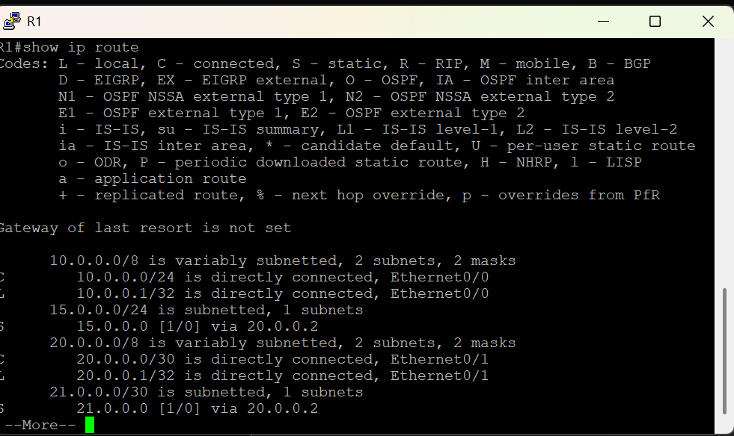
I configured static routing between six routers. I used /24 for end-device LANs and /30 for point-to-point router links. Connected routes are learned automatically, while remote networks are manually configured with static routes using next-hop IP addresses. I verified the interfaces and routing tables and then tested end-to-end connectivity with ping. Return routes are also required for successful two-way communication.
Output : R1

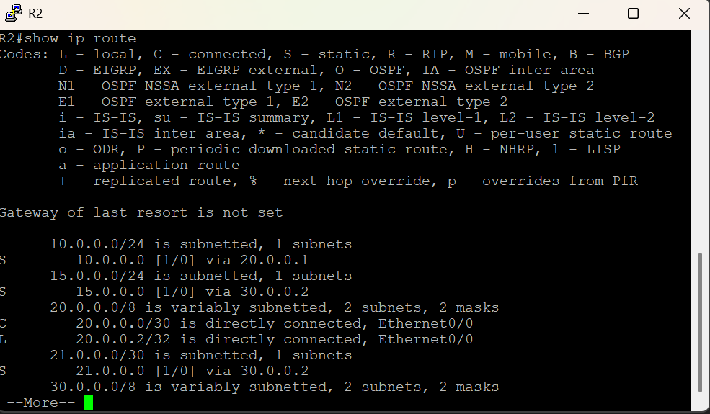

Output : Router2

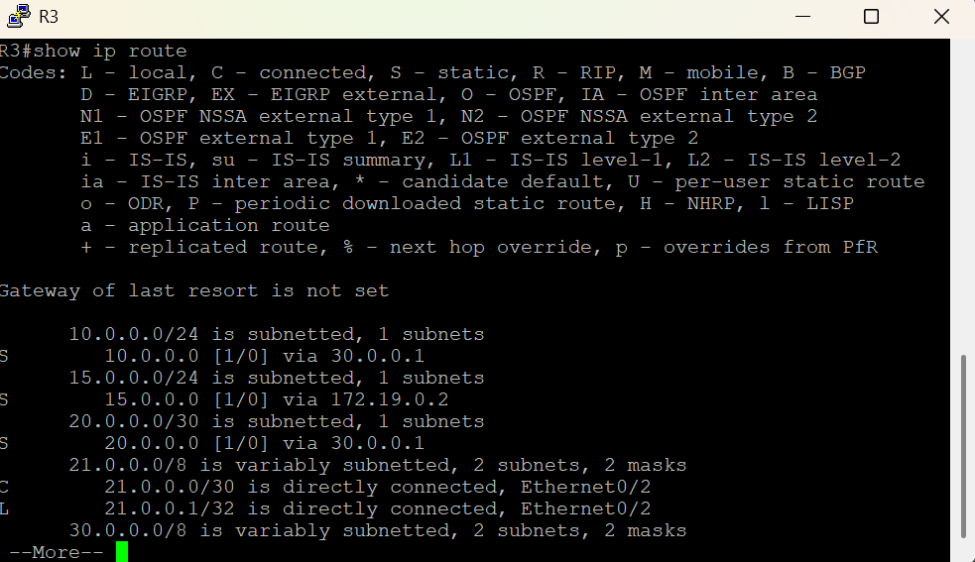

Output Router3 :

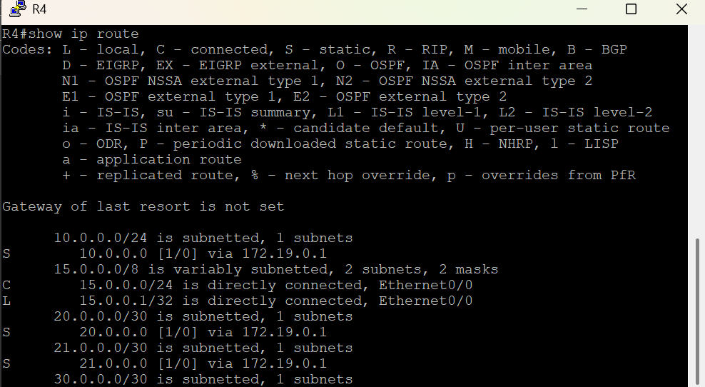
Output Router 4 :

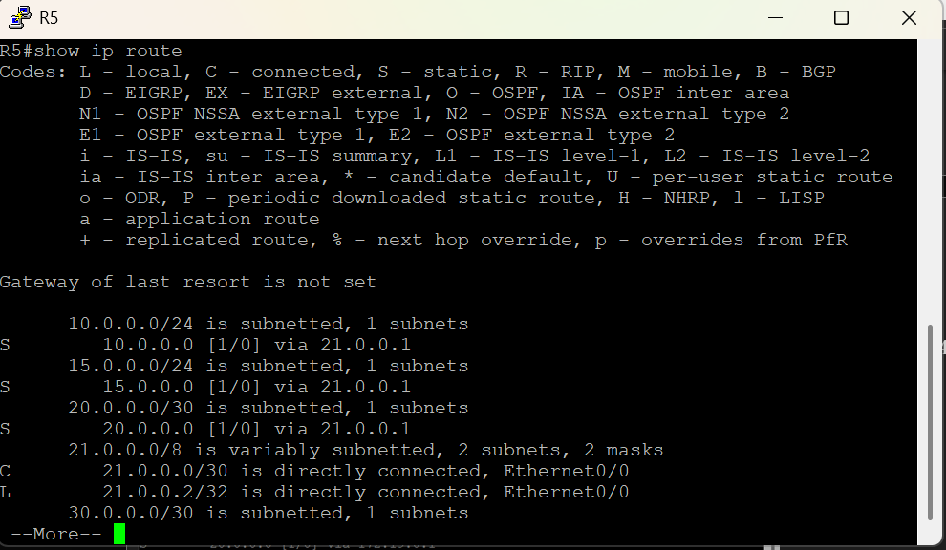
Output Router 5 :

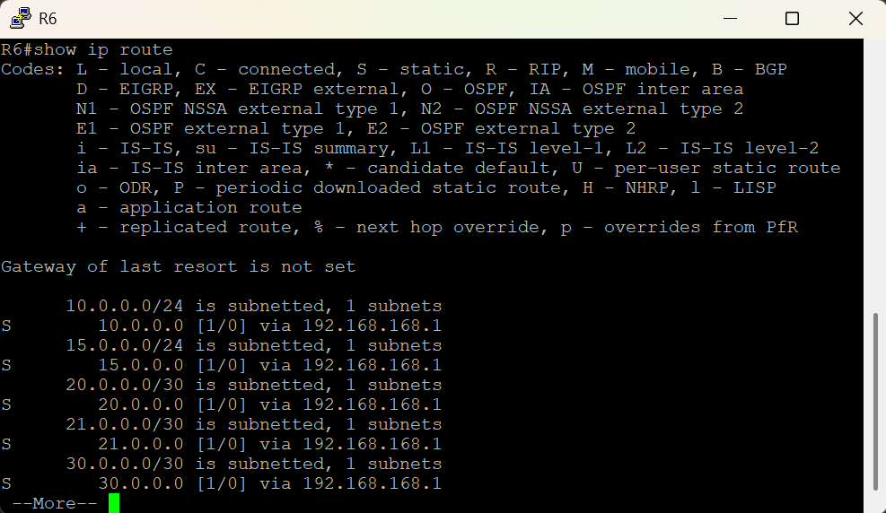

Output Router 6 :

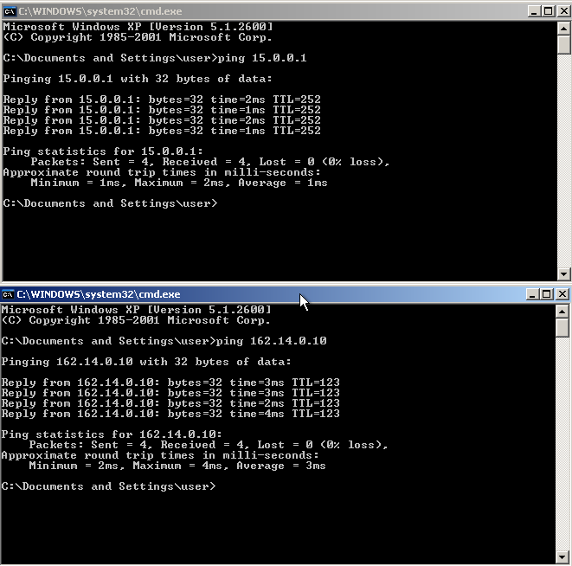
Output PC 1

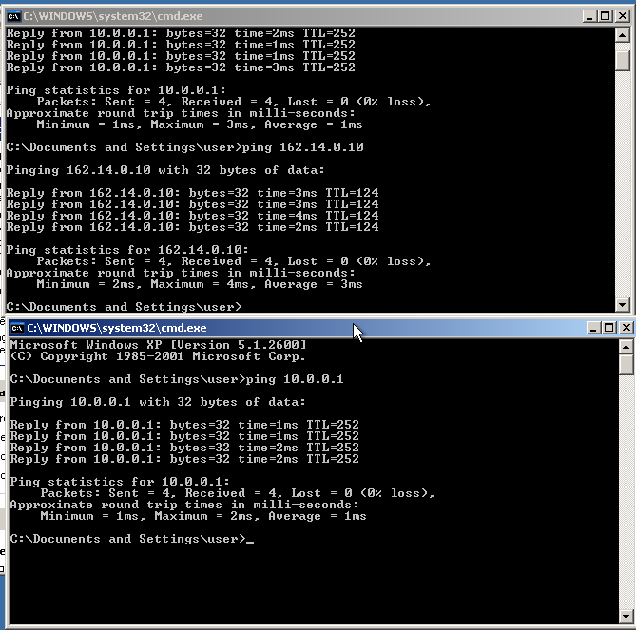
Output PC 2

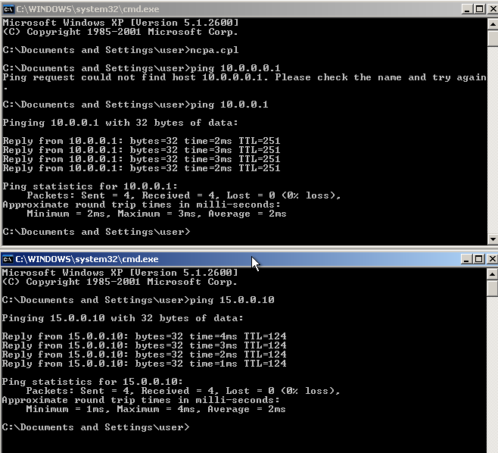

Output PC 3

